**Corrosion**

**Introduction to corrosion :**

**T**he word corrosion is as old as the earth, but it has been known by different names. Corrosion is known commonly as rust, an undesirable phenomena which destroys the luster and beauty of objects and shortens their life.

Several definitions of corrosion have been given and some of them are reproduced below:

(A) Corrosion is the surface wastage that occurs when metals are exposed to reactive environments.

(B) Corrosion is the result of interaction between a metal and environments which results in its gradual destruction.

(C) Corrosion is an aspect of the decay of materials by chemical or biological agents.

(E) Corrosion is the deterioration of materials as a result of reaction with its environment

(F) Corrosion is the destructive attack of a metal by chemical or electrochemical reaction with the environment .

**Corrosive Environment**

Corrosion cannot be defined without a reference to environment. All environments are corrosive to some degree. Following is the list of typical corrosive environments:

(1) Air and humidity.

(2) Fresh, distilled, salt and marine water.

(3) Natural, urban, marine and industrial atmospheres.

(4) Steam and gases, like chlorine.

(5) Ammonia.

(6) Hydrogen sulfide.

(7) Sulfur dioxide and oxides of nitrogen.

(8) Fuel gases.

(9) Acids.

(10) Alkalies.

(11) Soils.

Cost of Corrosion :

* In Japan, the cost of corrosion is estimated to be 5258 trillion Yen per year. For most industrialized nations, the average corrosion cost is 3.5–4.5% of the Gross National Product **(**GNP).
* In UK, the corrosion cost is estimated to be 4–5% of the GNP. Major annual corrosion losses to the tune of £350 million in transport, £280 million in

marine, £250 million in buildings and construction and £180 million in oil and chemical industries, have been reported in UK .

* About $120 billion is spent on maintenance of aging and deterioration infrastructures in USA

Corrosion has a serious impact on defense equipment. In the Gulf War, a serious problem of rotor blade damage in helicopter was caused by the desert sand. The thickness of the blade was reduced to 2–3mm in some instances.

The desert erosion–corrosion offered a new challenge to corrosion scientists and engineers. The storage of defense equipment is a serious matter for countries with corrosive environments, such as Saudi Arabia, Malaysia and South-East Asia.

Humidity is the biggest killer of defense hardware.

Why we study the corrosion :

We study the corrosion for many reasons such as :

1. Engineering knowledge is incomplete without an understanding of corrosion.

Aeroplanes, ships, automobiles and other transport carriers cannot be designed without any recourse to the corrosion behavior of materials used in these structures.

1. Several engineering disasters, such as crashing of civil and military aircraft, naval and passenger ships, explosion of oil pipelines and oil storage tanks, collapse of bridges and decks and failure of drilling platforms and tanker trucks have been witnessed in recent years. Corrosion has been a very important factor in these disasters. Applying the knowledge of corrosion protection can minimize such disasters. In USA, two million miles of pipe need to be corrosion-protected for safety.
2. The designing of artificial implants for the human body requires a complete understanding of the corrosion science and engineering. Surgical implants must be very corrosion-resistant because of corrosive nature of human blood.
3. Corrosion is a threat to the environment. For instance, water can become contaminated by corrosion products and unsuitable for consumption. Corrosion prevention is integral to stop contamination of air, water and soil.

**THE CORROSION REACTION**

Corrosion may be defined as: “The destruction of a metal or its properties by chemical or electro-chemical reaction with its environment”.

The dissolution of the metal is electro-chemical in nature. That is, it is basically a chemical reaction accompanied by the passage of an electric current.

For corrosion to occur, all of the following conditions must be present:

(1) There must be an anode and a cathode.

(2) There must be a potential difference between the anode and the cathode.

(3) There must be a metallic path connecting the anode and the cathode.

(4) There must be a conducting electrolyte surrounding both the anode and the cathode.

The anode is the area at which oxidation or corrosion occurs where the current leaves the metal to enter the electrolyte.

The cathode is the area at which reduction or negligible corrosion occurs where the current leaves the electrolyte to enter the metal.

The electrolyte is a solution in which the conduction of electric current occurs by the passage of dissolved ions.

When the above conditions are met an electric current will flow and metal will be consumed at the anode, i.e. the anode corrodes. See Fig. 1.

|  |
| --- |
|  |

Type of Corrosion :

* ***Dry corrosion***

This is the direct oxidation of metals which occurs when a freshly cut surface reacts with the oxygen of the atmosphere. Most of the corrosion-resistant metals such as lead, zinc and aluminum form a dry oxide film which protects the metal from further atmospheric attack.

* ***Wet corrosion***

This occurs in two ways:

a) The oxidation of metals in the presence of air and moisture, as in the

rusting of ferrous metals.

b) The corrosion of metals by reaction with the dilute acids in rain due to the burning of fossil fuels (acid rain) - for example, the formation of the

carbonate 'patina' on copper. This is the characteristic green film seen on

the copper clad roofs of some public buildings.

* ***Galvanic corrosion***

This occurs when two dissimilar metals, such as iron and tin or iron and zinc, are in intimate contact. They form a simple electrical cell in which rain, polluted with dilute atmospheric acids, acts as

an electrolyte as generated and circulates within the system. Corrosion

occurs with (depending upon its position in the electrochemical series) being eaten away.

Other metals, in addition to iron and steel, corrode when exposed to the

atmosphere. The green corrosion-product which covers a copper roof, or

the white, powdery film formed on some unprotected aluminum alloys is clear evidence of this. as soon as it is exposed to the atmosphere it forms an oxide film which seals the surface and prevents further corrosion from taking place.

On the other hand, iron is less reactive and forms its to oxide film more slowly. Unfortunately, the iron hydroxide film (rust) is porous and the process continues unabated until the metal is destroyed.

It has already been stated that when two dissimilar metals come into intimate association in the presence of an electrolyte that a simple electrical cell is formed resulting in the eating away of one or other of the metals. Metals can be arranged in a special order called the electrochemical series. This series is listed in Table 1 and it should be noted that, in this context, hydrogen gas behaves like a metal.

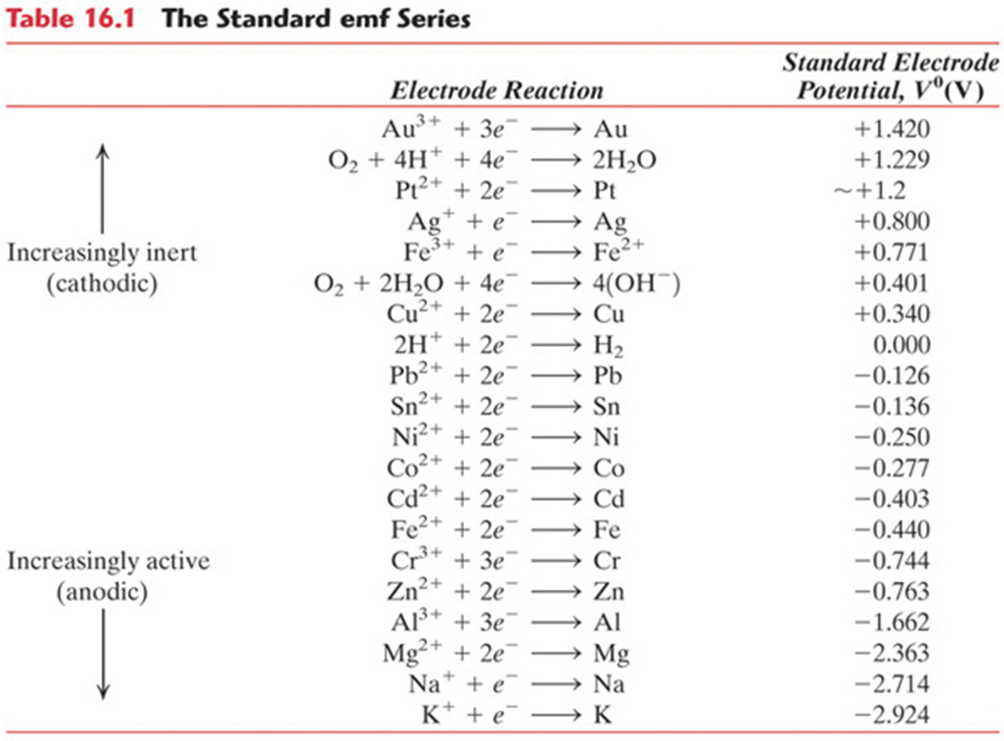

Table(1): The EMF standard series (Electromotive Force)

 V

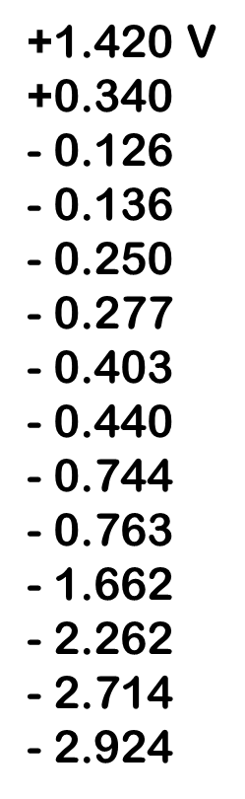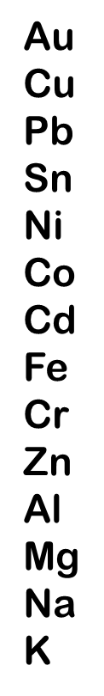

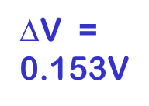



Metal with smaller

V corrodes.

Ex: Cd-Ni cell

* **Localized Corrosion:**

Unlike general attack corrosion, localized corrosion specifically targets one area of the metal structure. Localized corrosion is classified as one of two types:

* **Pitting corrosion :** results when a small hole, or cavity, forms in the metal, usually as a result of de-passivation of a small area This is a localized type of attack, with the rate of corrosion being greater at some areas than at others. If appreciable attack is confined to a relatively small, fixed area of metal, acting as anode, the resultant pits are described as deep. If the area of attack is relatively larger and not so deep, the pits are called shallow. Depth of pitting is sometimes expressed by the *pitting factor* , the ratio of deepest metal penetration to average metal penetration as determined by the weight loss of the specimen. A pitting factor of unity represents uniform attack. as shown in figure 3

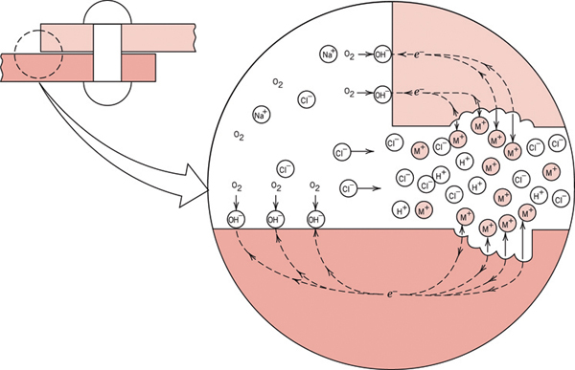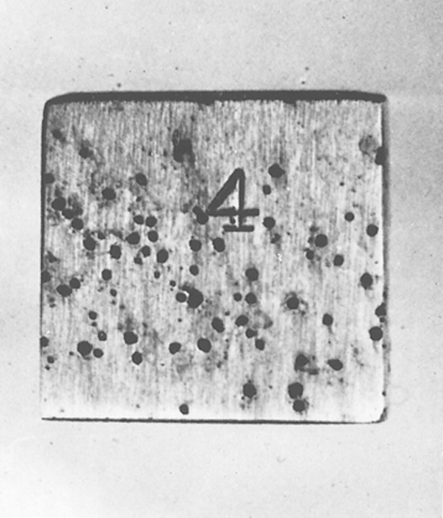

**Figure (3) Pitting corrosion**

* **Crevice corrosion**: Similar to pitting, crevice corrosion occurs at a specific location. This type of corrosion is often associated with a stagnant micro-environment, like those found under gaskets and washers and clamps. Acidic conditions, or a depletion of oxygen in a crevice can lead to crevice corrosion.
* **Erosion Corrosion:**

Causes by abrasive fluids impinging on surfaces Commonly found in piping, propellers, turbine blades, valves and pumps as shown in figure (4)

Solutions:

* Change design to minimize or eliminate fluid turbulence and impingement effects.
* Use other materials that resist erosion
* Remove particulates from fluids

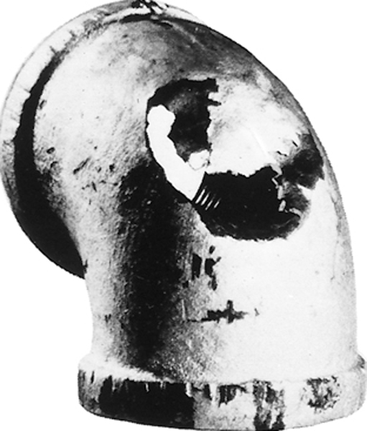

**Figure (4) Erosion corrosion**

**Corrosion accelerated by mechanical stresses:**

We have seen that failure of a component may take place due to corrosion arising from electrolytic action between two different phases in a microstructure, or between two different materials in a fabricated structure. Failure of a component may also occur as a result of the complementary effects of chemical corrosion and mechanical stress. The methods of stress application may vary and this will affect

the extent of corrosion which occurs. Forms of corrosion in which stress

plays a part can be classified as follows:

1. **Stress Corrosion**. In a cold-worked metal the pile-up of dislocations at crystal boundaries and other points increases the energy in those regions so that they become anodic to the rest of the structure. Consequently, corrosion takes place in these regions of high energy and the locked-up stresses give rise to the formation of cracks which grow progressively with the continuance of corrosion. Cracks grow along grain boundaries as a result of residual or applied stress

A similar process may take place in components in which unequal heating or cooling has given rise to the presence of locked-up stresses, as, for example, near to welded joints. See figure (5).

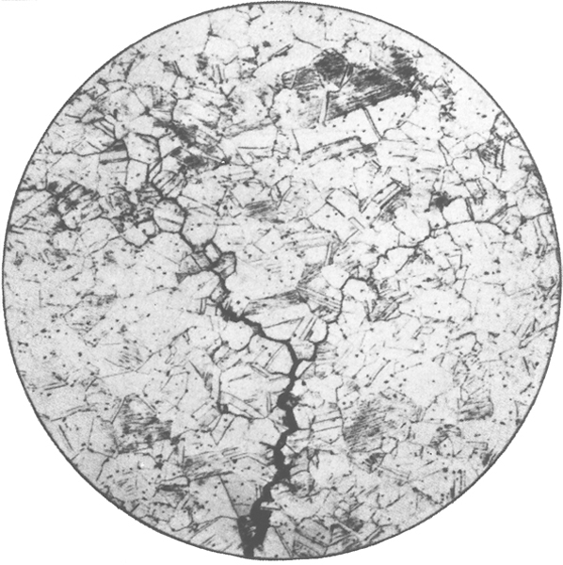

Figure (5) : stress corrosion

**Corrosion Fatigue**. As might be expected, any component which is subjected to alternating stresses and is working in conditions which promote corrosion may fail at a stress well below the normal fatigue limit. The action of the corrosive medium will tend to be concentrated at any surface flaw and behave as a focal point for the initiation of a fatigue crack. Once a crack has been formed it will spread more rapidly as a result of the corrosive action combined with alternating stress.

**Factors affecting corrosions:-**

***1. Structural design***

The following factors should be observed during the design stage of a component or assembly to reduce corrosion to a minimum.

• The design should avoid crevices and corners where moisture may become trapped, and adequate ventilation and drainage should be provided.

• The design should allow for easy washing down and cleaning.

• Joints which are not continuously welded should be sealed, for example,

by the use of mastic compounds or impregnated tapes.

• Where dissimilar metals have to be joined, high-strength epoxy adhesives

should be considered since they insulate the metals from each other and prevent galvanic corrosion.

• Materials which are inherently corrosion resistant should be chosen or, if this is not possible, an anti-corrosive treatment should be specified.

***2. Environment***

The environment in which the component or assembly is to spend its service life must be carefully studied so that the materials chosen, or the anticorrosion treatment specified, will provide an adequate service life at a reasonable cost.

***3. Applied or internal stresses***

Chemical and electrochemical corrosion is intensified when a metal is under stress. This applies equally to externally applied and internal stresses, although more common in the latter case. Internal stresses are usually caused by cold working and, if not removed by stress-relief heat treatment, results in corrosive attack along the crystal boundaries. This weakens the metal considerably more than simple surface corrosion. An example of intercrystalline corrosion is the 'season cracking' of a brass after severe cold working.

Intercrystalline corrosion occurs at the grain boundaries of crystals not only when impurities are present but also when stress concentrations are present. Grain boundaries are regions of high energy levels, even in very pure metals, so corrosion tends to occur more quickly at the grain boundaries.

Severely cold-worked α brasses are prone to ‘season cracking'. Here, intercrystalline corrosion follows the grain boundaries until the component is no longer able to sustain the internal stresses due to cold working. The component then cracks. This can be prevented by a lowtemperature stress relief annealing process. This low temperature does not cause recrystallisation but is sufficient to remove the locked up stresses by allowing the atoms to move small distances nearer to their equilibrium positions.

***4. Composition and structure***

* The presence of impurities in non-ferrous metals reduces their corrosion resistance. Hence the high level of corrosion resistance exhibited by high purity copper, aluminum and zinc.
* The importance of grain structure has also been mentioned above, and a fine-grain structure is generally less susceptible to corrosion than a coarse-grain structure.
* The inclusion of certain alloying elements such as nickel and chromium can also improve corrosion resistance - for example, the stainless steels and cupro-nickel alloys.

***5. Temperature***

For all chemical reactions there is a critical temperature below which they will not take place. Since corrosion is the result of chemical or electrochemical reactions, corrosion is retarded or stopped altogether at low temperatures.

**The protection of corrosion:-**

The metallic surface can be insulated from the corrosive medium by some form of protective coating. Such as coatings include various types of paints and varnishes, Metallic films having good corrosion-resistance and artificially thickened oxide films.

All of these are generally effective in protecting surfaces from atmospheric corrosion, though zinc coatings are used to protect iron from the rusting action of water, whilst tin coatings offer protection against most animal and vegetable juices encountered in the canning industry.

There are many types of the protection from corrosion, which they are:-

* 1. **Protection by Metallic Coatings**

One way of supplying this negative charge is to apply a coating of a more active metal. Thus a very common way of protecting steel from corrosion is to coat it with a thin layer of zinc; this process is known as galvanizing.The zinc coating, being less noble than iron, tends to corrode selectively. Dissolution of this sacrificial coating leaves behind electrons which concentrate in the iron, making it cathodic and thus inhibiting its dissolution.



A number of methods are available for the production of metallic coatings.

The most widely used are either electro-plating or dipping the articles to be

coated into a bath of the molten metal. In some cases a successful coating can

be produced by heating the articles to be coated in the finely powdered metal,

whilst specialised use is made of the process known as "cladding".

**1.1 *Cladding***.

This process is applicable chiefly to the manufacture of "clad" sheet. The

basis metal is sandwiched between pieces of the coating metal, and the

sandwich is rolled to the required thickness. "Alclad", which is duralumin

coated with pure aluminum, is possibly the best known of these products,

whilst "Niclad" (nickel-coated steel) is also manufactured.



Figure 6. Sectional through clad metal composite.

**1.2 *Coating by means of a spray of molten metal***

Metal spraying consists in projecting "atomised" particles of molten metal from a special pistol by a stream of compressed air on to a suitably prepared surface. Surface preparation usually involves blasting the surface with an abrasive; steel grit having replaced sharp silica sand for this purpose on account of the silicosis hazards involved when the latter is used.

The metal most commonly used for spraying is zinc, though coatings of aluminium, tin, lead, solder, cadmium, silver, copper and stainless steel can be deposited in this way.

Metal spraying has wide application in view of its portability and flexibility; thus, large structures, such as storage tanks, pylons and bridges, can be sprayed on site.

**1.3 *Electro-plating***

The formation of metal coatings by electro-deposition is well known, and a wide variety of metals can be thus used, including copper, nickel, chromium, cadmium, gold and silver. Tin and zinc can also be electro-deposited, and a coating thus formed has advantages over one produced by hot-dipping in respect of flexibility, uniformity and control of thickness of film.

In the actual process of electro-plating the article to be plated is made the cathode in an electrolytic cell. Sometimes the metal to be deposited is contained, as a soluble salt, in the electrolyte, in which case the anode is a nonreactive conductor, such as stainless steel, lead or carbon. In most cases, however, the anode consists of a plate of the pure metal which is being deposited, whilst the electrolyte will contain a salt or salts of the same metal.

Then, the anode gradually dissolves and maintains the concentration of the metal in the electrolyte as it is deposited on to the articles forming the cathode.

The conditions under which deposition takes place are very important, so that the cell voltage, the current density (measured in amperes per square meter of cathode surface), the ratio of anode area to cathode area and the time of deposition, as well as the composition and temperature of the electrolyte, must all be strictly controlled if a uniform adherent and non-ferrous film is to be obtained.



Figure 7. The electro plating.

**2) Protection by other nonmetallic coatings**

Coatings of this type usually offer only a limited protection against corrosion .

***2.1 Phosphating***

A number of commercial processes fall under this heading, but in all of them a coating of phosphate is produced on the surface of steel or zinc-base alloys by treating them in or with a solution of acid phosphates.

In order that the metal shall be made rust-proof a finishing treatment with varnish, paint, oil or lacquer is required.

***2.2 Chromating***

Chromate coatings are produced on magnesium-base alloys, and on zinc and its alloys, by immersing the articles in a bath containing potassium bichromate along with various other additions. The colour of the films varies with the bath and alloy, from yellow to grey and black.

1. **Cathodic protection**

This method of protection against corrosion can be used for buried or submerged pipe-lines and other structures. The pipe-line is made to act as a cathode by burying near it pieces of a metal which is much more electropositive than the iron of the pipe-line. These pieces of metal will therefore be anodic towards the iron of the pipe-line and will corrode sacrificially.

Alternatively, a current from D.C. mains can be passed through the soil or

water on to the metallic surface concerned so as to keep it at a slightly negative potential with respect to its surroundings. When electric power is available this will be the cheaper method, since electricity can be obtained more cheaply from the mains than from any electro-chemical source.

To protect the whole surface of a pipe-line by this means, however, would be

expensive, but if the pipe has already been coated with paint or some other

non-metallic substance, so that it is only necessary to protect any defective

areas, the power cost is small, since very small currents only are necessary.



Figure 8. Cathodic protection

**Expressions and Measures of Corrosion Rates**

There are three main methods that are used to express the corrosion rate:

a) Thickness reduction of the material per unit time.

b) Weight loss per unit area and unit time.

c) Corrosion current density.

Thickness reduction per unit time is the measure of most practical significance and interest. In the metric system this measure is usually expressed in mm/year. In some literature one can still find the unit mils per year (mpy) = 1/1000 inches per year, possibly also inches per year (ipy).

Weight loss per unit area and unit time was commonly used in earlier times, mainly because weight loss was usually the directly determined quantity in corrosion testing. Here the test specimens were weighed before and after the exposure to the corrosion medium. On this basis one could calculate the thickness reduction as weight loss per unit area/density.

From Figure 1 it can be understood that corrosion rate also can be expressed by corrosion current density. The dissolution rate (the corrosion rate) is the amount of metal ions removed from the metal per unit area and unit time.

This transport of ions can be expressed as the electric current Ia per area unit, i.e. anodic current density ia = corrosion current density icorr.

The relationship between thickness reduction per time unit ds/dt (on each

corroding side of the specimen/component) and the corrosion current density icorr is determined from Faraday’s equations:



where icorr is given in A/cm2;

z = number of electrons in the reaction equation for the anodic reaction

(dissolution reaction) (per atom of the dissolving metal);

M = the mol mass of the metal (g/mol atoms) (the numerical value of M

is the atomic weight of the metal);

F = Faraday’s constant = 96,485 coulombs/mole electrons = 96,485

C/mol e–≈ 96,500 As/mol e.

ρ = the density of the metal (g/cm3).

Table( 2 )shows the conversion factors between the units of corrosion rates that are most frequently used in the literature. Note that, for most of the listed materials, a corrosion current density of 1 µA/cm2 corresponds to a thickness reduction of roughly 0.01 mm/year. As an example of practical corrosion rates it can be mentioned that structural steels in seawater normally corrode by 0.1–0.15 mm/year on average. The corrosion rate can be a few times higher locally.

